**Projecting Daily Highs** & **Lows**



>-- Mosl Buy D11ys

ldcalStllDilyS CrutcllOD

ldulBuyDay,

Cn:art'LOD

|  |  |  |
| --- | --- | --- |
|  | 4 Standard Deviation |  |
| 3 Standard Deviation |
|  | 2 Standard Deviation |
| I Standud Deviation |
| Central Bank Dulers Range |  |
|  | I Standard Deviation |
| 2 Standard Deviation |
| 3 Standard Deviation |  |
| 4 Standard Deviation |

|  |  |  |
| --- | --- | --- |
|  | 4 Standard Deviation |  |
|  | J Standard Deviation |
| 2 Standard Deviation |
| I Standard Deviation |
| Ccntnl Bank IkalcN Range |  |
|  | 1 Standard DeYiation |
| 2 Standard Deviation |
| 3 Standard Deviation |
| 4 Standard Deviation |  |

Cn:1111:LOD

Everything ICT teaches you have to do the same thing on the wicks as well

|  |  |
| --- | --- |
| t  Using the PD Array Matrix with  Time & Price Theory |  |
|  |

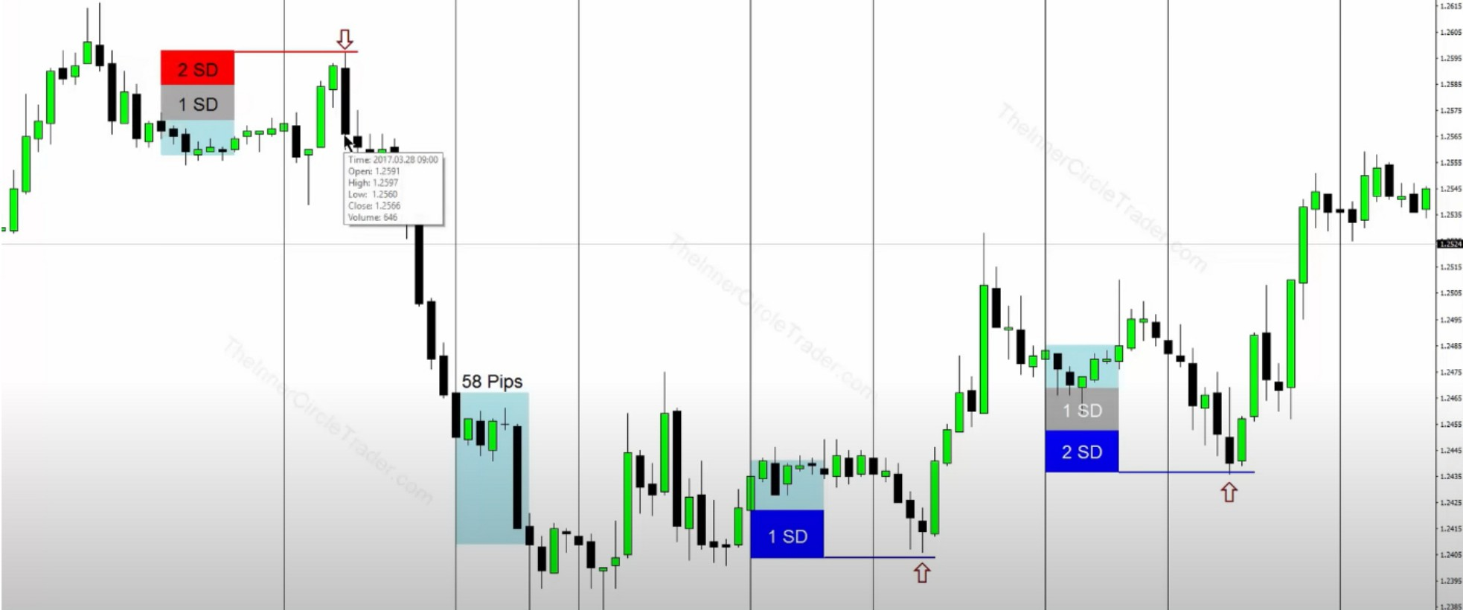

Daily Bullish Orderblock

The standard deviations line up with PD arrays

The entire standard deviations + CBDR that becomes your measurement for the opposite low/high of the day in london close

Draw the measurements until we reach london close

If we still have a daily PD array we can reach as in the example, then the london close probably

wont do much and we can hold some profits trough it

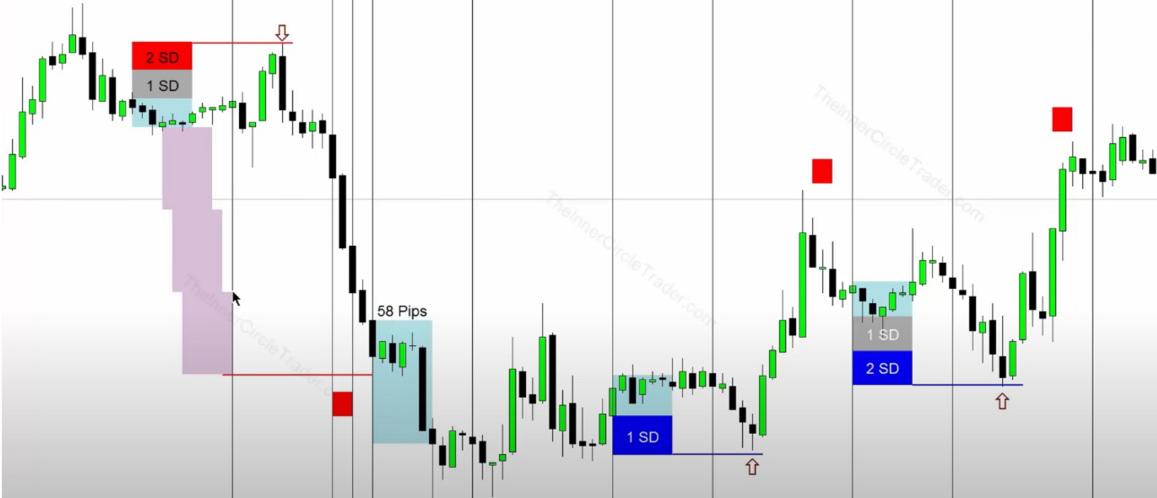

Daily Bullish Orderblock

Make sure the standard deviations line up with a PD array

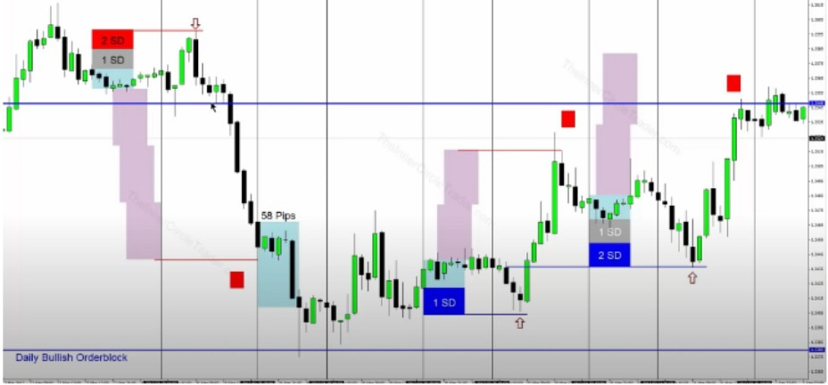

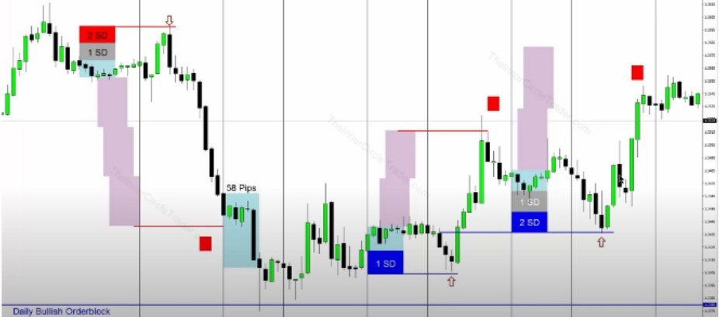

ICT likes to just use 2 standard deviations to the opposite side just to see what would line up

Both the standard deviations down and up line up with PD arrays, its not just the standard deviations, blend them together with PD arrays

The PD arrays call the shots, its not the magic of the projections ICT uses 1h chart for this

Remember it has to be less than 40 and you have to have directional bias Now we can filter out the days we want to trade, based on the CBDR

Arjo I Twitter, lnstagram I Linktree

Linktree. Make your link do more. https://t.co/HhmmTN1fUI

JavaScript is not available.

https://twitter.com/arjoio